How to install VLC media player on Linux RHEL/CentOS root user


VLC is a free and open source cross-platform multimedia player and framework that plays most multimedia files as well as DVDs, Audio CDs, VCDs, and various streaming protocols.
Features:
1.Simple, fast and powerful media player.
2.Plays everything: Files, Discs, Webcams, Devices and Streams.
3.Plays most codecs with no codec packs needed:
MPEG-2, DivX, H.264, MKV, WebM, WMV, MP3...
4.Runs on all platforms: Windows, Linux, Mac OS X, Unix...
5.Completely Free, no spyware, no ads and no user tracking.
6.Can do media conversion and streaming.
Install latest VLC player on your CentOS 6.5 Operating System. If that’s you, then the step by step guide below will help you to install VLC on your machine. Please note that for earlier versions of CentOS, you might run into some dll dependencies. if you do, then post the errors encountered.
Steps to install VLC Media player on ur Linux RHEL/CentOS
Step1: Download Repository for VLC
change to repository configuration directory
# cd /etc/yum.repos.d/
Download repository using wget command
# wget http://pkgrepo.linuxtech.net/el6/release/linuxtech.repo
step2: Chack the vlc package in download repository using yum command
# yum --enablerepo=linuxtech-release list *vlc*

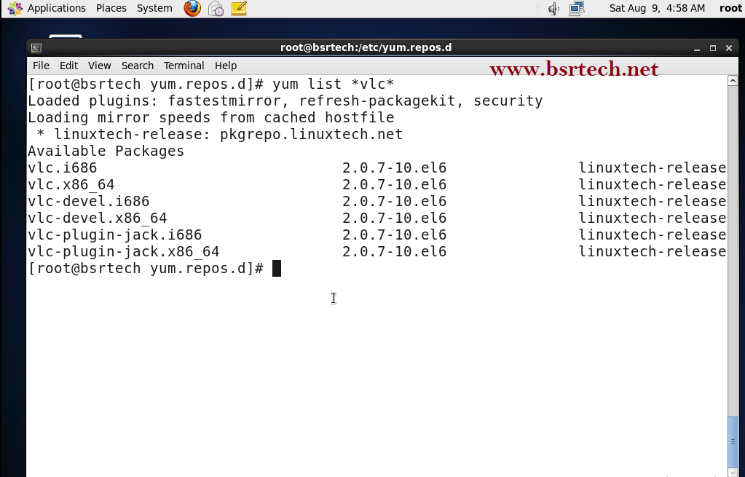
step3: Install VLC using yum
# yum --enablerepo=linuxtech-release install *vlc*
Installation process is running based on OS Architecture, after complete the installation launch VLC .

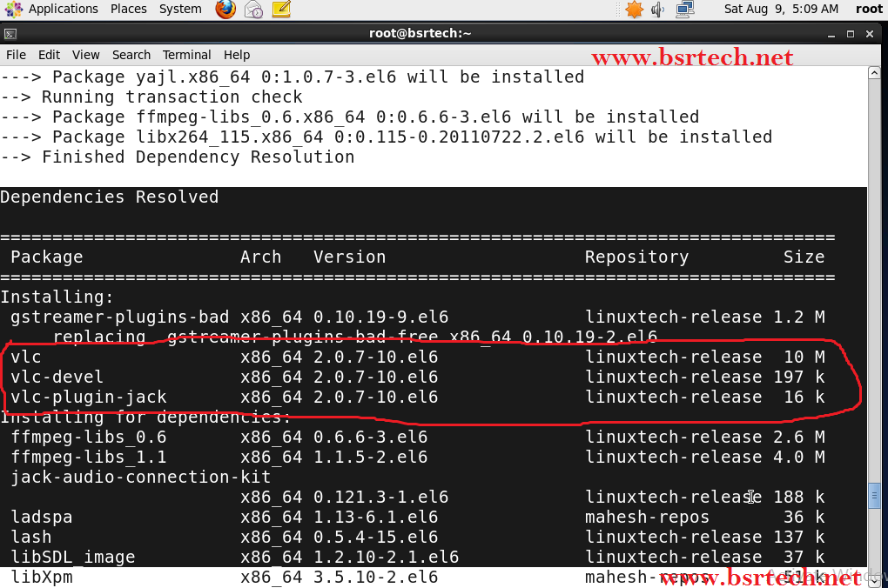
Step4: Open VLC Player
CUI(command-line) : #vlc &
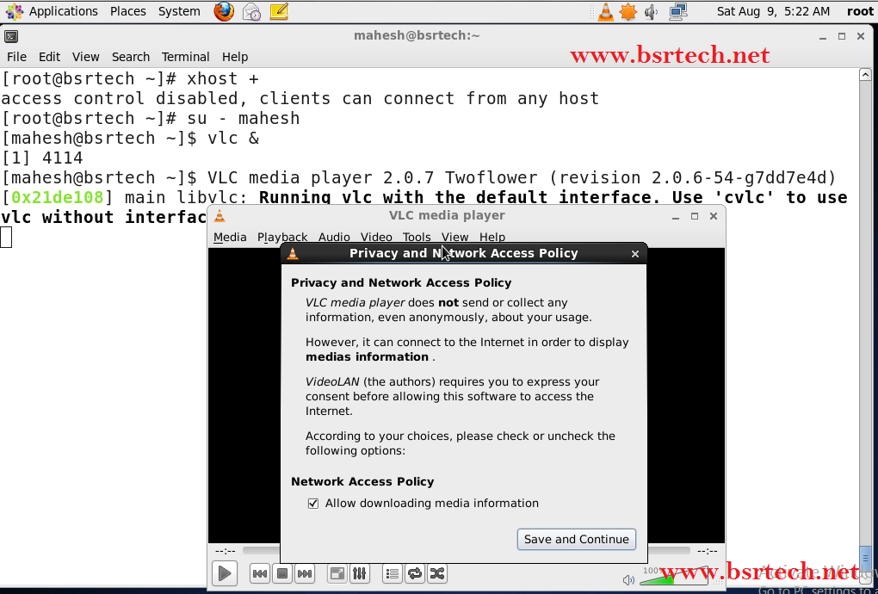
GUI(Graphical) : Applications -> Sound&Video -> VLC media player
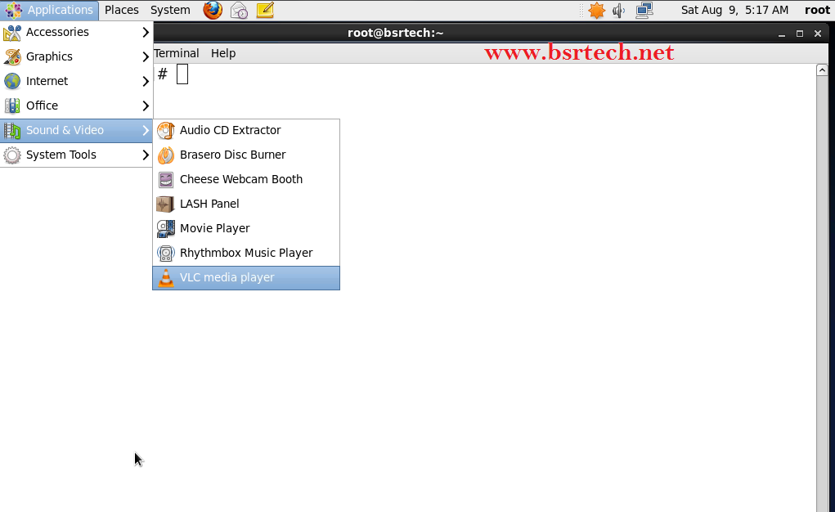

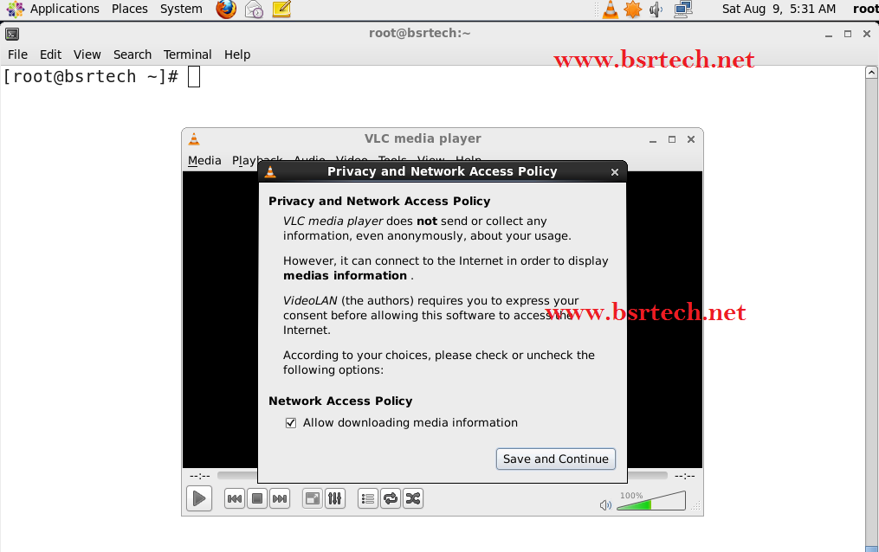
Note : Remember you have to be normal user to run VLC Player, You cannot Run VLC Player as root.
Step5: If Run Root User Execute Below Script
open below configuration file and change
#vi /usr/bin/vlc
search for geteuid and replace it with getppid
Save file & Exit.

